PREDICTION OF COVID-19 USING SUPERVISED MACHINE LEARNING ALGORITHM

Harshitha P1, Maddina Sireesha2 , Kiruthika K3

3Assistant professor

12Finalyear students

***Abstract— Machine learning (ML) based forecasting mechanisms have proved their significance to anticipate in preoperative outcomes to improve the decision making on the future course of actions .The ML models have long been used in many application domains which needed the identification and prioritization of adverse factors for a threat. Several prediction methods are being popularly used to handle forecasting problems. The ML models to forecast the number of upcoming patients affected by COVID-19 which is presently considered as a potential threat to mankind. The COVID -19 predicts the cases in particular area using machine learning algorithms.***

***Keyword – CIOVID-19 PREDICTION, SUPERVISED MACHINE LEARNING ALGORITHM***

I.INTRODUCTION

Machine learning (ML) has proved itself as a prominent field of study over the last decade by solving many very complex and sophisticated real-world problems. The application areas included almost all the real-world domains such as healthcare, autonomous vehicle (AV), business applications, natural language processing (NLP), intelligent robots, gaming, climate modeling, voice, and image processing. ML algorithms’ learning is typically based on trial and error method quite opposite of conventional algorithms, One of the most significant of ML is forecasting, numerous standard ML algorithms have been used in this area to guide the future course of actions needed in many application areas including weather forecasting, disease forecasting, stock market forecasting as well as disease prognosis. Various regression and neural network models have wide applicability in predicting the conditions of patients in the future with a specific disease.

2. MACHINE LEARNING:

Machine learning (ML) is the study of computer algorithms that improve automatically through experience and by the use of data.It is seen as a part of artificial intelligence. Machine learning algorithms build a model based on sample data, known as "[training data](https://en.wikipedia.org/wiki/Training_data)", in order to make predictions or decisions without being explicitly programmed to do so. Machine learning algorithms are used in a wide variety of applications, such as [email filtering](https://en.wikipedia.org/wiki/Email_filtering) and [computer vision](https://en.wikipedia.org/wiki/Computer_vision), where it is difficult or unfeasible to develop conventional algorithms to perform the needed tasks. A subset of machine learning is closely related to [computational statistics](https://en.wikipedia.org/wiki/Computational_statistics), which focuses on making predictions using computers; but not all machine learning is statistical learning. The study of [mathematical optimization](https://en.wikipedia.org/wiki/Mathematical_optimization) delivers methods, theory and application domains to the field of machine learning. [Data mining](https://en.wikipedia.org/wiki/Data_mining) is a related field of study, focusing on [exploratory data analysis](https://en.wikipedia.org/wiki/Exploratory_data_analysis) through [unsupervised learning](https://en.wikipedia.org/wiki/Unsupervised_learning).In its application across business problems, machine learning is also referred to as [predictive analytics](https://en.wikipedia.org/wiki/Predictive_analytics). Machine learning involves computers discovering how they can perform tasks without being explicitly programmed to do so. It involves computers learning from data provided so that they carry out certain tasks. For simple tasks assigned to computers, it is possible to program algorithms telling the machine how to execute all steps required to solve the problem at hand; on the computer's part, no learning is needed. For more advanced tasks, it can be challenging for a human to manually create the needed algorithms. In practice, it can turn out to be more effective to help the machine develop its own algorithm, rather than having human programmers specify every needed step.

The discipline of machine learning employs various approaches to teach computers to accomplish tasks where no fully satisfactory algorithm is available. In cases where vast numbers of potential answers exist, one approach is to label some of the correct answers as valid. This can then be used as training data for the computer to improve the algorithm(s) it uses to determine correct answers. For example, to train a system for the task of digital character recognition, the MNIST dataset of handwritten digits has often been used. Machine learning approaches are traditionally divided into three broad categories, depending on the nature of the "signal" or "feedback" available to the learning system:

[Supervised learning](https://en.wikipedia.org/wiki/Supervised_learning): The computer is presented with example inputs and their desired outputs, given by a "teacher", and the goal is to learn a general rule that [maps](https://en.wikipedia.org/wiki/Map_(mathematics)) inputs to outputs.

[Reinforcement learning](https://en.wikipedia.org/wiki/Reinforcement_learning): A computer program interacts with a dynamic environment in which it must perform a certain goal (such as [driving a vehicle](https://en.wikipedia.org/wiki/Autonomous_car) or playing a game against an opponent). As it navigates its problem space, the program is provided feedback that's analogous to rewards, which it tries to maximize.

Other approaches have been developed which don't fit neatly into this three-fold categorisation, and sometimes more than one is used by the same machine learning system. For example [topic modeling](https://en.wikipedia.org/wiki/Topic_modeling), [dimensionality reduction](https://en.wikipedia.org/wiki/Dimensionality_reduction) or [meta learning](https://en.wikipedia.org/wiki/Meta_learning_(computer_science)). As of 2020,deep learning has become the dominant approach for much ongoing work in the field of machine learning

## **3.EXISTING SYSTEM**

.

In earlier days the disease prediction is done by identifying the symptoms of covid-19 in patients. The prediction begins from this identification. The datasets are collected and prediction is done with the help of the available Data using random forest algorithm in machine learning.

**DRAWBACK OF EXISTING SYSTEM**

The prediction can be done only after the patient is affected by the disease.

We can only predict at the later stage and hence cannot be predicted before the patient is affected. Dengue cannot be fully avoided only we can control the affects caused by it Dengue disease prediction accuracy is very low.

**4.PROPOSED SYSTEM**

Corona virus spread has conducted the society under the edge of loss in social lives. Additionally, it is crucial to investigate the transmission growth ahead and predict the future occurrences of the transmission.

In concurrent, state-of-the-art mathematical models are chosen based on machine learning for a computational process to predict the spread of the virus, for instance

Machine learning and deep learning strategies are performed using the python library to predict the total number confirmed, recovered, and death cases extensively.

This prediction will allow undertaking specific determinations based on transmission growth, such as expanding the lockdown phase, performing the sanitation plan, and providing daily support and supplies. In this segment, we’re going to generate a week ahead forecast of confirmed cases of COVID-19 usingProphet, with specific prediction intervals by creating a base model both with and without tweaking of seasonality-related parameters and additional regressors. Prophet is open source software released by Facebook’s Core Data Science team. It is available for download on CRAN and PyPI We use Prophet, a procedure for forecasting time series data based on an additive model where non-linear trends are fit with yearly, weekly, and daily seasonality, plus holiday effects. It works best with time series that have strong seasonal effects and several seasons of historical data. Prophet is robust to missing data and shifts in the trend, and typically handles outliers well. On predicting the dengue fever at the earlier stage, we can reduce the number of deaths caused by it .The **accuracy** is very high when compared to the existing system .Timely Prediction of covid is the only way to outbreak the disease.

Region wise prediction is done Less effort is need for pre-processing the dataset.Scaling and normalization of data is not required.

**5.ARCHITECTURAL DIAGRAM**

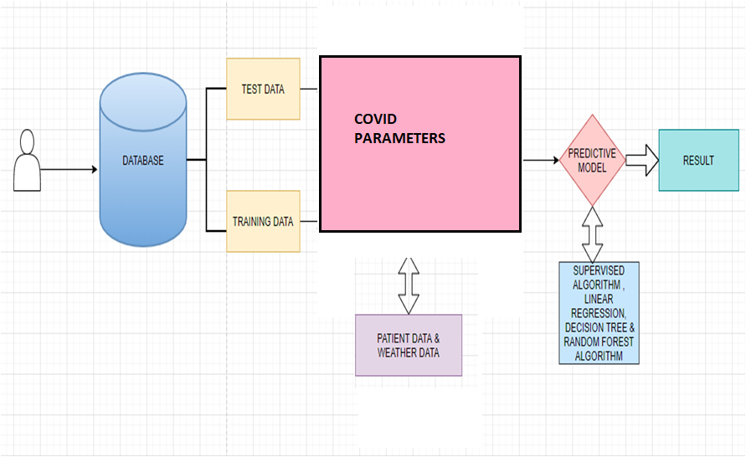

**6. MODULES:**

DATA COLLECTION

* Compare the patient medical details with the data sets
* Apply the Supervised machine Learning algorithm for the datasets to predict the Covid-19 Cases.

DATA PREPROCESSING

* The dataset contains last 6 months values

The dataset contains null values. The null values cannot process by the programming hence these values need to convert into numerical values

TREND ANALYSIS

* At this point, India had already crossed 10M cases. It still is very important to contain the situation in the coming days.
* The numbers of corona virus patients had started doubling after many countries hit the large cases, and almost starting increasing exponentially.

VISUALIZATION DATA FOR OTHER COUNTRIES

* At this point, India had already crossed 10M cases. It still is very important to contain the situation in the coming days.
* The numbers of corona virus patients had started doubling after many countries hit the large cases, and almost starting increasing exponentially.

PREDICTION MODEL

* Compare the patient medical details with the data sets
* Apply the Supervised machine Learning algorithm for the datasets to predict the Covid-19 Cases.

**7.CONCLUSION**

Modeling will show us which features, and which combination of features, will be good predictors of the number of cases. However, it is important to remember that it is not the current weather that determines the number of covid-19 cases. The next post will look into determining the monthly trend .After that, I will describe methods to use historical weather to predict the current amount of Covid-19 fever cases.

**8.REFERENCES**

[1] S. Makridakis, E. Spiliotis, and V. Assimakopoulos, ‘‘Statistical and machine learning forecasting methods: Concerns and ways forward,’’ PLoS ONE, vol. 13, no. 3, Mar. 2018, Art. no. e0194889.

[2] G. Bontempi, S. B. Taieb, and Y.-A. Le Borgne, ‘‘Machine learning strategies for time series forecasting,’’ in Proc. Eur. Bus. Intell. Summer School. Berlin, Germany: Springer, 2012, pp. 62–77.

[3] F. E. Harrell Jr, K. L. Lee, D. B. Matchar, and T. A. Reichert, ‘‘Regression models for prognostic prediction: Advantages, problems, and suggested solutions,’’ Cancer Treat. Rep., vol. 69, no. 10, pp. 1071–1077, 1985.

[4] P. Lapuerta, S. P. Azen, and L. Labree, ‘‘Use of neural networks in predicting the risk of coronary artery disease,’’ Comput. Biomed. Res., vol. 28, no. 1, pp. 38–52, Feb. 1995.

[5] K. M. Anderson, P. M. Odell, P. W. Wilson, and W. B. Kannel, ‘‘Cardiovascular disease risk profiles,’’ Amer. heart J., vol. 121, no. 1, pp. 293–298, 1991.

[6] H. Asri, H. Mousannif, H. A. Moatassime, and T. Noel, ‘‘Using machine learning algorithms for breast cancer risk prediction and diagnosis,’’ Procedia Comput. Sci., vol. 83, pp. 1064–1069, Jan. 2016.

[7] F. Petropoulos and S. Makridakis, ‘‘Forecasting the novel coronavirus COVID-19,’’ PLoS ONE, vol. 15, no. 3, Mar. 2020, Art. no. e0231236.

[8] G. Grasselli, A. Pesenti, and M. Cecconi, ‘‘Critical care utilization for the COVID-19 outbreak in lombardy, italy: Early experience and forecast during an emergency response,’’ JAMA, vol. 323, no. 16, p. 1545, Apr. 2020.

[9] WHO. Naming the Coronavirus Disease (Covid-19) and the Virus That Causes it. Accessed: Apr. 1, 2020. [Online]. Available: https:// www.who.int/emergencies/diseases/novel-coronavirus-2019/technic% alguidance/naming-the-coronavirus-disease-(covid-2019)-and-the-virusthat-cau%ses-it

[10] C. P. E. R. E. Novel, ‘‘The epidemiological characteristics of an outbreak of 2019 novel